Name: Rakesh Rahul R
Department: Information Technology
Stream: BTech
Year: 3

Mask R-CNN
Step 1: Installation
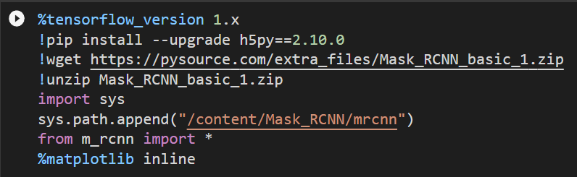
This code will install the Tensorflow of version 1.x into the Google Colab.
** I learned this from pysource.com, and have followed the procedure.
First, I have installed and upgraded the file from the link which contains a zip file. Then I unzipped it.
Importing sys is essential to perform these tasks.
Matplotlib is nothing but a MATLAB plotting library file with this only we can able to create a mask layers and other plotting actions.
When we run this code I got the output as, 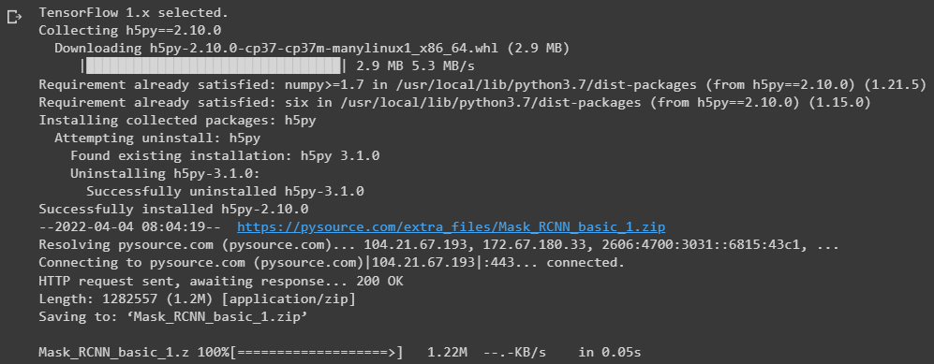
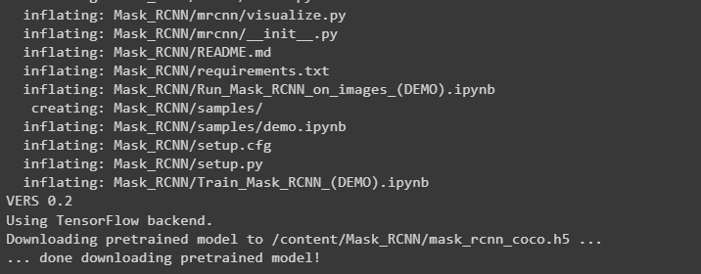

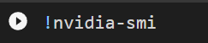
This code will enable the GPU actions
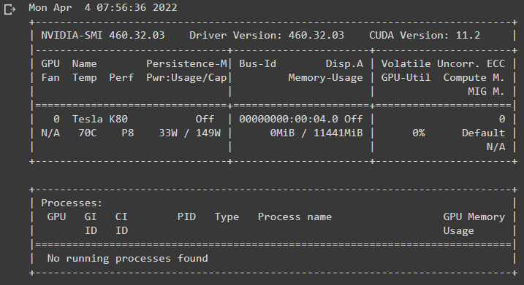

Step 2: Importing image dataset
Before doing this I have downloaded a set of images of laptop. Then I used the website called makesence through this website I have drawing a polygon outline around the laptop for each and every image that I have downloaded before. Then assigned labels to the outlines. Finally, I have downloaded the Annotation file in json format through this only I will train the model in the upcoming stages.
Now I opened a notebook in google colab, there I imported the zip file of images dataset, and json file which I have downloaded from the website.
Then I renamed the zip file as “images.zip” and for json file “laptop.json”
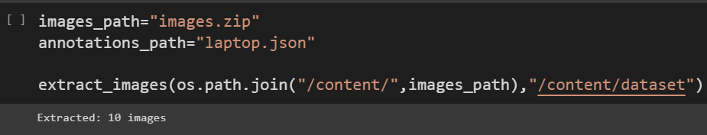
With this code I extracted the images from the zip file.
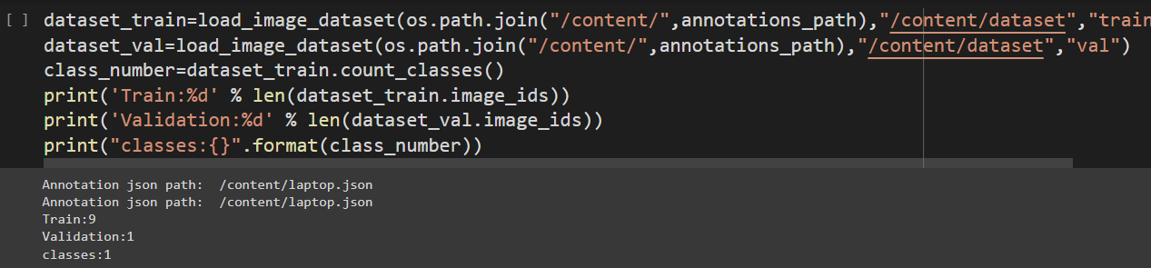
Here the annotation file that is laptop.json file has been checked.
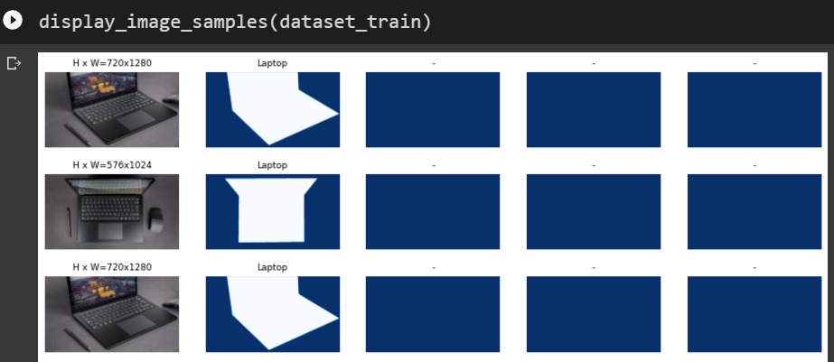
This code will the output for the trained images
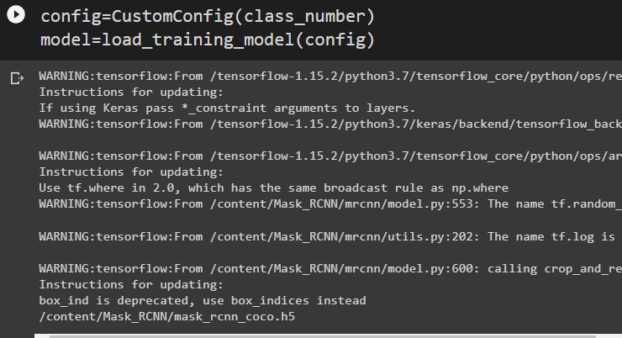
The above code will prepare the model for training it.

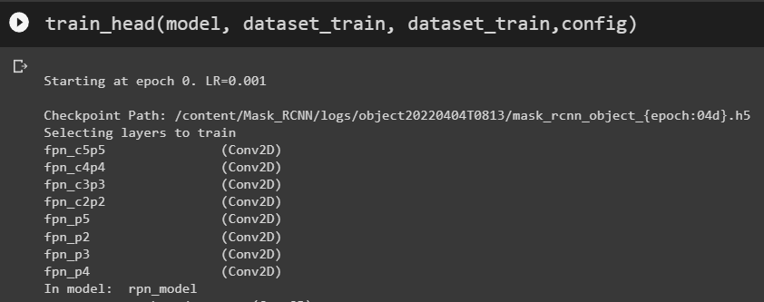
Now the training stars it has to complete 5 stages one by one. Need some time for it’s training.
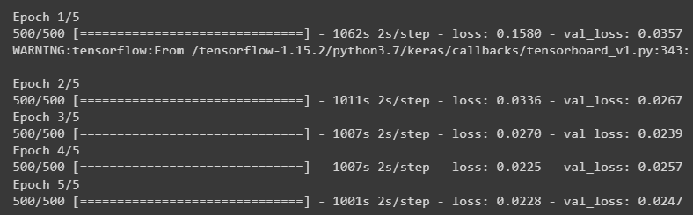
After the training gets over the above is the output.

The next step is Detecting the object using the trained model:
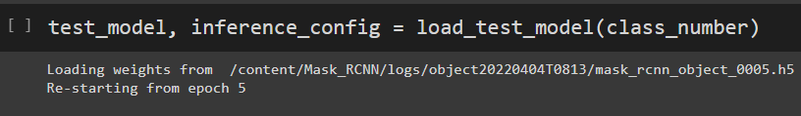
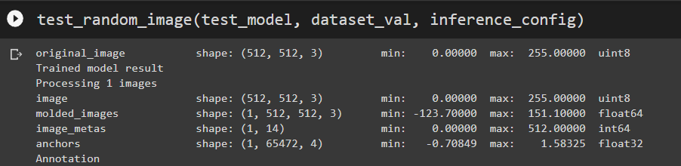

The final image with annotation is below:
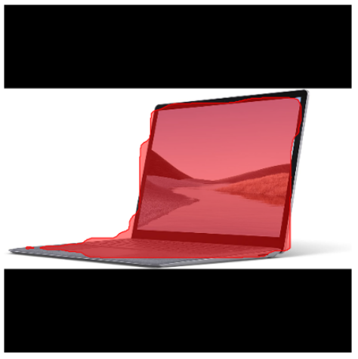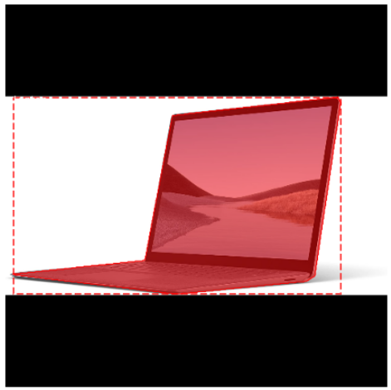
Right side image is the output got for me with the random image chosen from the dataset what I gave

